

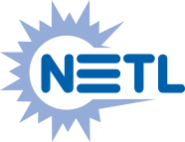

**Intellectual Property Management Plan**

**February 28, 2011**

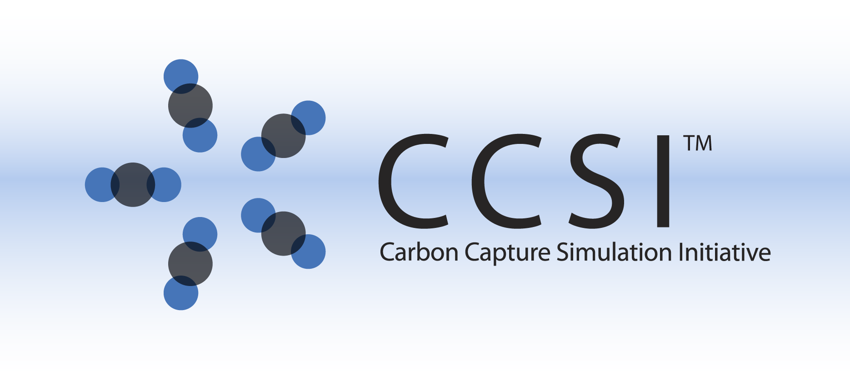

BOILER INSTALLATION GUIDE

Version 2.0.0

March 2018

Copyright (c) 2012 - 2018

**Copyright Notice**

Boiler Model was produced under the DOE Carbon Capture Simulation Initiative (CCSI), and is copyright (c) 2012 - 2018 by the software owners: Oak Ridge Institute for Science and Education (ORISE), Los Alamos National Security, LLC., Lawrence Livermore National Security, LLC., The Regents of the University of California, through Lawrence Berkeley National Laboratory, Battelle Memorial Institute, Pacific Northwest Division through Pacific Northwest National Laboratory, Carnegie Mellon University, West Virginia University, Boston University, the Trustees of Princeton University, The University of Texas at Austin, URS Energy & Construction, Inc., et al.. All rights reserved.

NOTICE. This Software was developed under funding from the U.S. Department of Energy and the U.S. Government consequently retains certain rights. As such, the U.S. Government has been granted for itself and others acting on its behalf a paid-up, nonexclusive, irrevocable, worldwide license in the Software to reproduce, distribute copies to the public, prepare derivative works, and perform publicly and display publicly, and to permit other to do so.

**License Agreement**

Boiler Model Copyright (c) 2012 - 2018, by the software owners: Oak Ridge Institute for Science and Education (ORISE), Los Alamos National Security, LLC., Lawrence Livermore National Security, LLC., The Regents of the University of California, through Lawrence Berkeley National Laboratory, Battelle Memorial Institute, Pacific Northwest Division through Pacific Northwest National Laboratory, Carnegie Mellon University, West Virginia University, Boston University, the Trustees of Princeton University, The University of Texas at Austin, URS Energy & Construction, Inc., et al. All rights reserved.

Redistribution and use in source and binary forms, with or without modification, are permitted provided that the following conditions are met:

1. Redistributions of source code must retain the above copyright notice, this list of conditions and the following disclaimer.
2. Redistributions in binary form must reproduce the above copyright notice, this list of conditions and the following disclaimer in the documentation and/or other materials provided with the distribution.
3. Neither the name of the Carbon Capture Simulation Initiative, U.S. Dept. of Energy, the National Energy Technology Laboratory, Oak Ridge Institute for Science and Education (ORISE), Los Alamos National Security, LLC., Lawrence Livermore National Security, LLC., the University of California, Lawrence Berkeley National Laboratory, Battelle Memorial Institute, Pacific Northwest National Laboratory, Carnegie Mellon University, West Virginia University, Boston University, the Trustees of Princeton University, the University of Texas at Austin, URS Energy & Construction, Inc., nor the names of its contributors may be used to endorse or promote products derived from this software without specific prior written permission.

THIS SOFTWARE IS PROVIDED BY THE COPYRIGHT HOLDERS AND CONTRIBUTORS "AS IS" AND ANY EXPRESS OR IMPLIED WARRANTIES, INCLUDING, BUT NOT LIMITED TO, THE IMPLIED WARRANTIES OF MERCHANTABILITY AND FITNESS FOR A PARTICULAR PURPOSE ARE DISCLAIMED. IN NO EVENT SHALL THE COPYRIGHT OWNER OR CONTRIBUTORS BE LIABLE FOR ANY DIRECT, INDIRECT, INCIDENTAL, SPECIAL, EXEMPLARY, OR CONSEQUENTIAL DAMAGES (INCLUDING, BUT NOT LIMITED TO, PROCUREMENT OF SUBSTITUTE GOODS OR SERVICES; LOSS OF USE, DATA, OR PROFITS; OR BUSINESS INTERRUPTION) HOWEVER CAUSED AND ON ANY THEORY OF LIABILITY, WHETHER IN CONTRACT, STRICT LIABILITY, OR TORT (INCLUDING NEGLIGENCE OR OTHERWISE) ARISING IN ANY WAY OUT OF THE USE OF THIS SOFTWARE, EVEN IF ADVISED OF THE POSSIBILITY OF SUCH DAMAGE.

You are under no obligation whatsoever to provide any bug fixes, patches, or upgrades to the features, functionality or performance of the source code ("Enhancements") to anyone; however, if you choose to make your Enhancements available either publicly, or directly to Lawrence Berkeley National Laboratory, without imposing a separate written license agreement for such Enhancements, then you hereby grant the following license: a non-exclusive, royalty-free perpetual license to install, use, modify, prepare derivative works, incorporate into other computer software, distribute, and sublicense such enhancements or derivative works thereof, in binary and source code form. This material was produced under the DOE Carbon Capture Simulation Initiative

Table of Contents

1. Introduction 1

2. Prerequisites 1

2.1. Hardwad 1

2.2. Software 1

2.2.1 Required third party software packages 1

3. Basic Installation 1

3.1. Third Party Software Installation 1

3.2. Building Product (For Developers Only) 2

3.2.1 Build Executable on Windows 2

3.2.2 Build Executable on Linux 3

3.3. Product Installation 3

3.3.1 Install Boiler Model Manually 3

3.3.2 Install Boiler Model Using Installer on Windows 3

4. Installation Problems 3

4.1. Known Issues/Fixes 3

4.2. Reporting Installation issues 3

# Introduction

Boiler Model is a software package that solves equations of the multi-phase flow, convective and radiative heat transfer, and reactions inside a pulverized coal-fired boiler. 3-D spatial discretization is employed to solve the radiative heat transfer equation using discrete ordinates method. The 3-D cells are assigned to multiple zones along the height of furnace, forming 1-D spatial resolution for equations related to mass flow, chemical reactions, and energy balance. This hybrid approach can dramatically reduce the number of variables to be solved; therefore, requires much less simulation time compared to typical Computational Fluid Dynamics (CFD) models. The first-principles-based model contains advanced submodels for the calculation of radiation properties and for the heterogeneous reactions between coal particle and the gas reactants. The Boiler Model is applicable to both air-firing and oxy-firing conditions. The short simulation time and reasonable accuracy of the Boiler Model enable the fast generation of reduced steady state model for an oxy-combustion boiler and incorporation of the reduced model to a large-scale multi-variable optimization framework for system-wise optimization of the oxy-combustion system with carbon capture.

# Prerequisites

## Hardwad

A computer run on Windows operating system or Linux.

## Software

Boiler Model is a software package that solves equations of the multi-phase flow, convective and radiative heat transfer, and reactions inside a pulverized coal-fired or other fossil-fuel-fired boiler. For those users who are not interested in further development, a Microsoft software installer “BoilerModelSetup.msi” is provided for the current version that can be installed on Windows platform (Windows 7 or higher). For developers who are interested in contributing to the boiler model, the executable can also be built on Windows by Microsoft Visual Studio and on Linux by gfortran and gcc.

### 2.2.1 Required third party software packages

For developers who are interested in future revision and enhancement of the software package, Microsoft Visual Studio (version 2012 or higher) is needed on Windows and gfortran is needed on Linux.

For end users who are not interested in modifying the source code, no computer language packages are needed. The installer will install binary executables and required libraries, along examples and documents.

# Basic Installation

## Third Party Software Installation

N/A

## Building Product (For Developers Only)

### 3.2.1 Build Executable on Windows

Developers need to install Microsoft Visual Studio (version 2012 or higher) on their Windows computer in order to compile and debug the program.

A third party package named “f2c” is also needed to compile “GasEmissivity.c” that is converted from a Fortran source code “GasEmissivity.f”. The f2c source code can be found at <http://www.netlib.org/f2c/>. Download “libf2c.zip” file and unzip the file. In the f2c’s source file directory, open Visual Studio prompt and issue the following command:

nmake –f makefile.vc all

A static library file named “vcf2c.lib” is created in the same directory. Copy this file to the “BoilerModel\f2c\lib_win32” folder under the boiler model’s source directory. Also copy the file named “f2c.h” to the “BoilerModel\f2c\include” folder.

To build the executable file “BoilerModel.exe”, follow the steps describe below.

1. Open the visual studio solution file “BoilerModel.sln” and Microsoft Visual Studio GUI displays as shown in Figure 1.

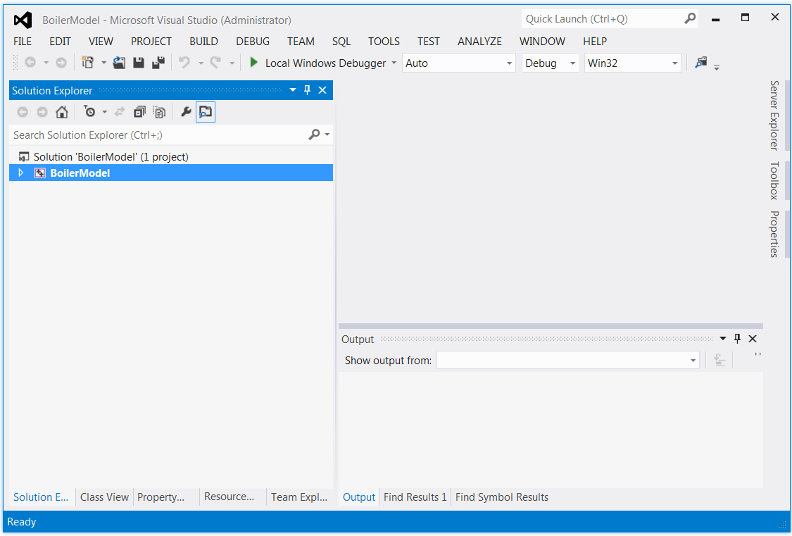

Figure 1. Visual Studio Window for Boiler Model Project

2. Click the dropdown box “Debug” and select “Release”. This allows Visual Studio to build a release version.

3. In the main window of Visual Studio, issue **Build→Build Solution** command. The “BoilerModel.exe” file will be created and written to the “Release” folder. Note the “Release” folder that contains the executable file is under the main folder of the boiler model project and there is also a “Release” folder created inside the “BoilerModel” folder that contains the object files.

### 3.2.2 Build Executable on Linux

If gfortran is not installed, install the gfortran compiler first. Then open a Linux window and change directory to the “BoilerModel” directory and is a “make” command. The “makefile” in the “BoilerModel” directory will be used to create the executable file “boilermodel”.

## Product Installation

### 3.3.1 Install Boiler Model Manually

Simply copy the executable file built in Section 3.2 to an installation directory and change the computer’s path to make the file executable in any directory.

### 3.3.2 Install Boiler Model Using Installer on Windows

For end users, simply run the provided Windows installer “BoilerModelSetup.msi”. Follow the instructions of the installer to complete the installation process. It is required that the user accept the license agreement displayed in one of the dialog window. The user also has the option to install the program in a user specified directory. The default directory is “C:\Program Files (x86)\CCSI\BoilerModel”. It also creates a shortcut on user’s desktop and adds the Boiler Model program to Windows’ “Start” menu. Note: An end user does not need to install any third party software packages.

# Installation Problems

## Known Issues/Fixes

N/A

## Reporting Installation issues

Contact [ccsi-support@acceleratecarboncapture.org](mailto:ccsi-support@acceleratecarboncapture.org).

The email of lead development team for this product is

[jinliang.ma@netl.doe.gov](mailto:jinliang.ma@netl.doe.gov),